A

Report of Miniproject On

Miniproject Title

**House Price Prediction**

Submitted in Partial Fulfillment of the Requirements of University of Mumbai for the Degree of

## Bachelor of Engineering (S.E. Computer Science Engineering – Artificial Intelligence and Machine Learning)

By

## Prachi Bhoir 03

**Suraj Nayak 22**

**Abhinav Patil 24**

**Shreyas Patil 29**

**Sahebraju Peerzade 31**

For Subject

**Miniproject** Under Supervision of **Prof. Shashikant Patil**

## Department of Computer Engineering Vishwaniketan’s Institute of Management, Entrepreneurship and

**Engineering Technology, Khalapur, Raigad University of Mumbai**

**Academic Year: 2021-22**

**CERTIFICATE**

This is to certify that the Mini Project work **“House Price Prediction”** done by

**Prachi Bhoir, Suraj Nayak, Abhinav Patil, Shreyas Patil, Sahebraju Peerzade,** student of “**Department Of Computer Science Engineering – Artificial Intelligence and Machine Learning”** is a record of bonafide work carried out of them. This Project is done as the part of syllabus of Second Year Computer Science Engineering – Artificial Intelligence and Machine Learning, for partial fulfillment of obtaining “**Bachelor of Computer Science Engineering – Artificial Intelligence and Machine Learning”** degree to be awarded by “**Vishwaniketan’s Institute of Management, Entrepreneurship and Engineering Technology, University of Mumbai”.**

**Supervisor/Guide Head of Department**

**Prof. Shashikant patil Prof. Shashikant patil**

**Principal :**

**Dr B.R. patil**

DATE: / /

## DECLARATION

We declare that this written submission represents our ideas in our own words and where others' ideas or words have been included, I have adequately cited and referenced the original sources. I also declare that we have adhered to all principles of academic honesty and integrity and have not misrepresented or fabricated or falsified any idea/data/fact/source in our submission. I understand that any violation of the above will be cause for disciplinary action by the Institute and can also evoke penal action from the sources which have thus not been properly cited or from whom proper permission has not been taken when needed.

Prachi bhoir 

Suraj nayak 

Abhinav patil 

Shreyas patil 

Sahebraju peerzade 

Names and Signatures of Students

## ACKNOWLEDGEMENT

We are profoundly grateful to **Prof. shashikant Patil** for his expert guidance and continuous encouragement throughout to see that this project rights its target since its commencement to its completion.

I would like to express a deepest appreciation towards Dr **B.R. Patil(Principal, ViMEET)** and Mr. Shashikant Patil,(**Head, Department of Computer Science Engineering – artificial intelligence and machine learning, ViMEET)** whose invaluable guidance and support in completing this project.

We express our sincere gratitude to all the staff members of computer science engineering department who helped us directly or indirectly during this course of work.

## ABSTRACT

**House Price Prediction**

Usually, the House price index represents the summarized price changes of residential housing. While for a single-family house price prediction, it needs a more accurate method based on location, house type, size, build year, local amenities, and some other factors which could affect house demand and supply. With limited dataset and data features, a practical and composite data pre-processing, creative feature engineering method is examined in this paper. The paper also proposes a hybrid Lasso and Gradient boosting regression model to predict individual house prices.

## Table of Content

|  |  |  |
| --- | --- | --- |
| **Section** | **Content** | **Page Number** |
|  | **ABSTRACT** | 5 |
| **1** | **INTRODUCTION** | 7 |
|  | 1.1 Introduction to House Price Prediction | 7 |
|  | 1.2 Need for House Price Prediction | 7 |
| **2** | **SYSTEM SPECIFICATION** | 7 |
|  | 2.1 Hardware Components Required | 7 |
|  | 2.2 Software Components Required | 8 |
| **3** | **PROJECT DESCRIPTION** | 8 |
|  | 3.1Problem Description |  |
| **4** | **SYSTEM STUDY & ANALYSIS** | 8 |
|  | 4.1Existing System | 8 |
|  | 4.2Proposed System | 9 |
|  | 4.3System Analysis | 9 |
|  | 4.4System Planning | 9 |
|  | 4.5Feasibility Study | 10 |
| **5** | **RESULTS** | 11 |
|  | Output / Screenshots | 13 |
|  | Code | 11 |
|  | Results Discussion | 13 |
| **6** | **FUTURE SCOPE** |  |
| **7** | **CONCLUSION** | 14 |
| **8** | **REFERENCES** | 14 |

1. **INTRODUCTION**

* **Introduction to Hose Price Prediction:**

This is the House price prediction project is based on data science.

Data science combines several disciplines including statistics, data analysis machine learning. What we are doing in this project is to train and test the data sets..and to clean and apply the Ml algorithms.

In this project, we are going to predict the house price of and then with the help of the visualization process, we will predict the house price prediction and see which area is having the low cost and which area is having the highest cost.

* + Need of the House Price Prediction:
* To fill the information gap
* To improve the real estate efficiency
* To know the price range according to area
* To analyze the data
* To show which area is having the high and less cost according to the location

1. SYSTEM SPECIFICATION
   1. Hardware Components Required: No hardware is required
   2. Software Components Required:

Google Colab

1. PROJECT DESCRIPTION

3.1Problem Description (Define the Problem) a] Identifying the problem

b] Collecting the data c] Cleaning the data

1. Train and Test the data
2. Apply the machine learning algorithm (Data preprocessing) f] Visualizing the data

g] Result

1. SYSTEM STUDY AND ANALYSIS
   1. Existing System: DESCRIPTION

This presents the characteristics and applications related to the House Price Prediction. The use of house price prediction helps people to predict the price with the help of the locations.

Advantages:

* To know the price range
* To plan financial well
* Property investing

Disadvantages:

* Calculation of the house price is done without the necessary prediction
* Price increases as the future trends and the market level changes
  1. Algorithms:

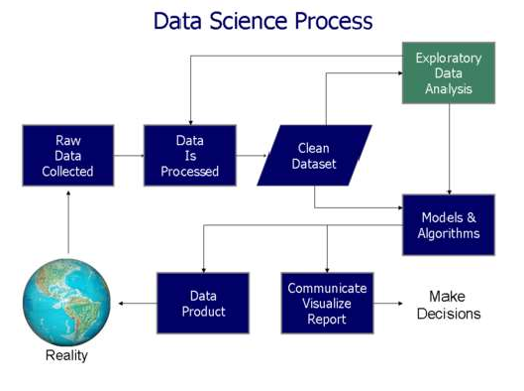

* 1. System feasibility

Technology:

This is done with the help of python technology .

Finance:

The thing only required to buy if required i.e GPU. Time:

The time required for it is for the loading the dataset because the data set consists of a large number of rows and columns and so it requires some time for the training and testing without GPU.

1. RESULTS
   1. CODE
   2. O/P / Screenshot
   3. Result

INPUTS

Code for the House Price Prediction:

#IMPORTING THE DEPENDENCIES

import numpy as np import pandas as pd

import matplotlib.pyplot as plt import seaborn as sns

import sklearn.datasets

from sklearn.model_selection import train_test_split from xgboost import XGBRegressor

#Importing the boston house price data set house_price_dataset =sklearn.datasets.load_boston() print(house_price_dataset)

#Loading the above data frame into the pandas data frame house_price_dataframe = pd.DataFrame(house_price_dataset.data,columns=h ouse_price_dataset.feature_names)

house_price_dataframe

#getting the first 5 rows from the data frame house_price_dataframe.head()

#to include the target to the data frame: house_price_dataframe['price']=house_price_dataset.target

print(house_price_dataframe)

#to calculate the shape house_price_dataframe.shape

#to check whether the dataset has the missing values house_price_dataframe.isnull().sum()

#To describe the statistical data: house_price_dataframe.describe()

#to get the mean median and the standard deviation house_price_dataframe.mean() house_price_dataframe.median() house_price_dataframe.std()

# To find the corelation between each of the two datasets:

1. Positive corelation
2. Negative Corelation

correlation=house_price_dataframe.corr()

correlation

#constructing the heastmap for the coorelation using the sns:#dark = +v e corr

plt.figure(figsize=(15,15))

sns.heatmap(correlation, cbar=True, square=True, fmt='.1f',annot=True, annot_kws={'size':9}, cmap='Blues')

#splliting the data and the target(price / label) X = house_price_dataframe.drop(['price'],axis=1) Y = house_price_dataframe['price']

print(X) print(Y)

Spltting the data into the training and testing

x_train, x_test, y_train, y_test = train_test_split(X, Y, test_size=0.2

, random_state=2)

print(X, x_train, x_test) # 80% for the training data and 20% for testi ng the data:

1. shape

x_train.shape

y_train.shape #Training the model

#Loading the data with the Regressor: model = XGBRegressor()

#Traing the data model with the training dataset: model.fit(x_train, y_train)

output:

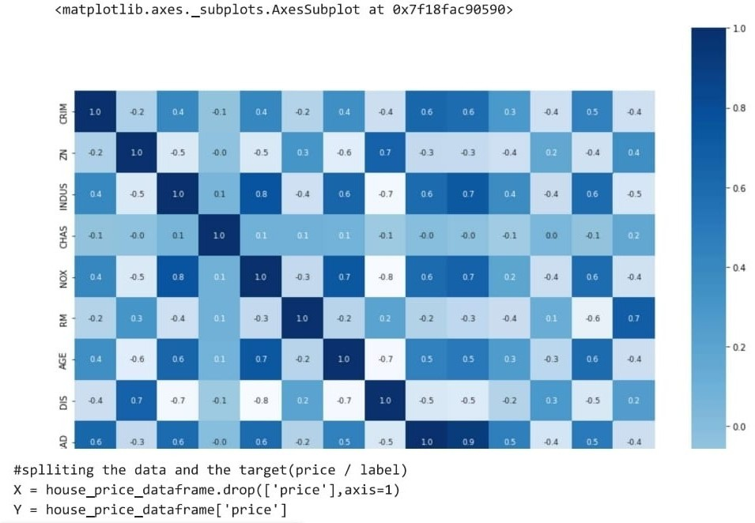

6.CONCLUSION

* + We have created a model that works to predict the house price by considering various factors that might affect the price. New analytical techniques of machine learning can be used in property research. This study is an exploratory attempt to use the machine learning algorithms in estimating housing prices and then compare their results.

REFERENCES

* + Dataset from Kaggle
  + Information from Google